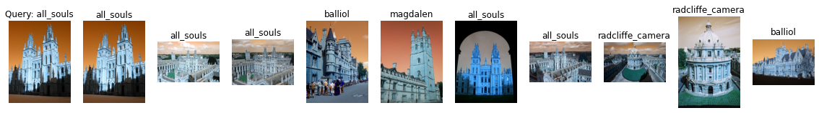

Label: all_souls

Average Precision for query 0: 0.4808342168690813

Precision@k for query 0: 0.5

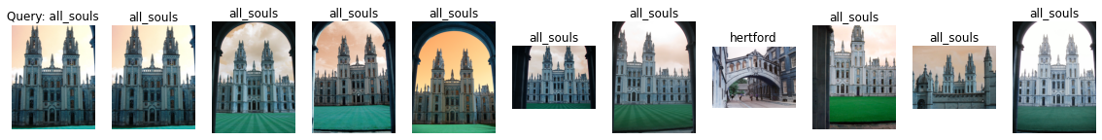

Label: all_souls

Average Precision for query 1: 0.5286890328636843

Precision@k for query 1: 0.9

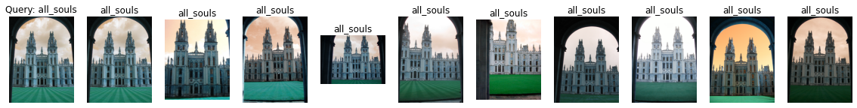

Label: all_souls

Average Precision for query 2: 0.6078466668230722

Precision@k for query 2: 1.0



Label: all_souls

Average Precision for query 3: 0.6220788640532402

Precision@k for query 3: 1.0

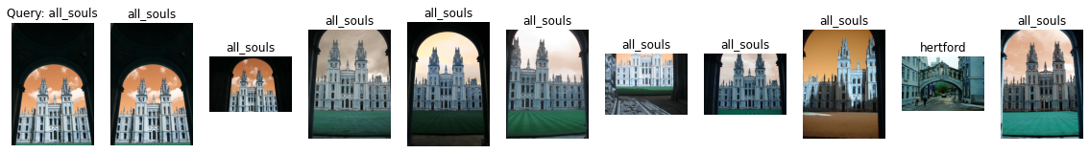

Label: all_souls

Average Precision for query 4: 0.6127514324260986

Precision@k for query 4: 0.9

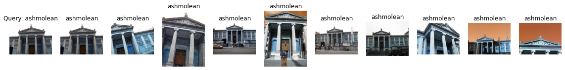

Label: ashmolean

Average Precision for query 5: 0.6155837056872113

Precision@k for query 5: 1.0

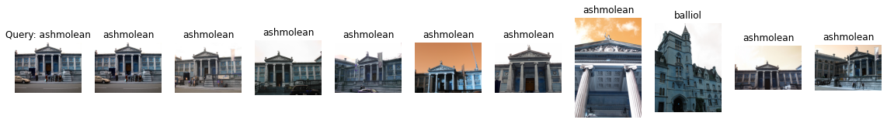

Label: ashmolean

Average Precision for query 6: 0.45871695315885413

Precision@k for query 6: 0.9

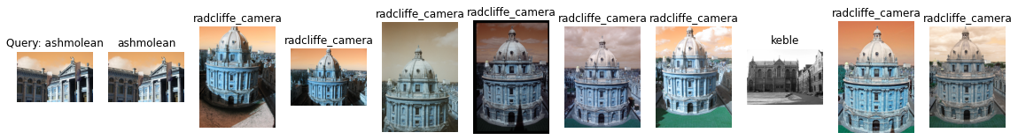

Label: ashmolean

Average Precision for query 7: 0.07416608337249998

Precision@k for query 7: 0.1

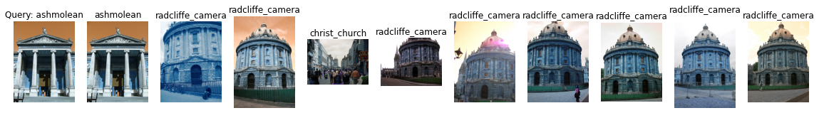

Label: ashmolean

Average Precision for query 8: 0.10750716557148221

Precision@k for query 8: 0.1

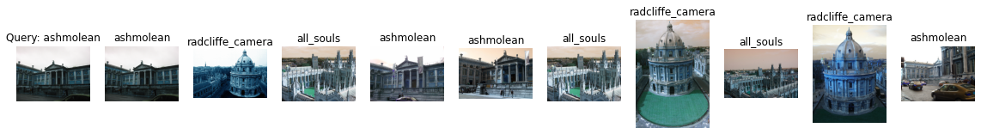

Label: ashmolean

Average Precision for query 9: 0.15950542395155

Precision@k for query 9: 0.4

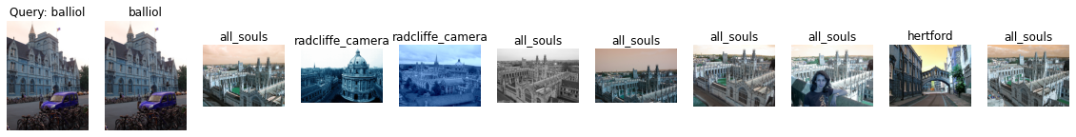

Label: balliol

Average Precision for query 10: 0.18531111565912817

Precision@k for query 10: 0.1

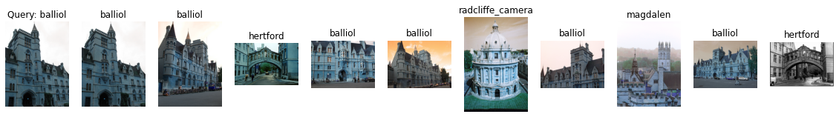

Label: balliol

Average Precision for query 11: 0.5202432576122011

Precision@k for query 11: 0.6



Label: balliol

Average Precision for query 12: 0.228696906409299

Precision@k for query 12: 0.2

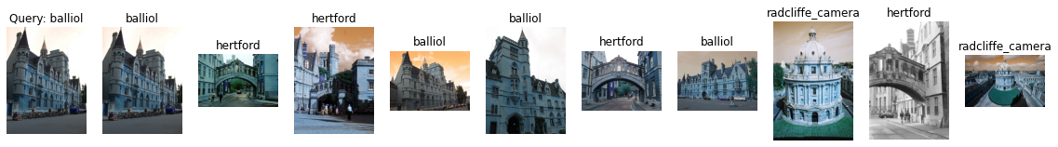

Label: balliol

Average Precision for query 13: 0.37430359653994655

Precision@k for query 13: 0.4

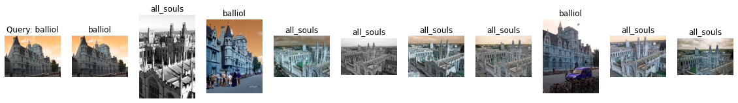

Label: balliol

Average Precision for query 14: 0.2965840734062158

Precision@k for query 14: 0.3

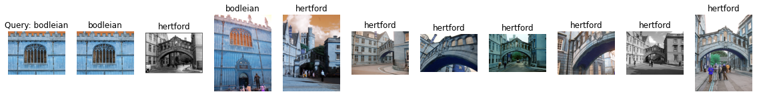

Label: bodleian

Average Precision for query 15: 0.129854019814338

Precision@k for query 15: 0.2

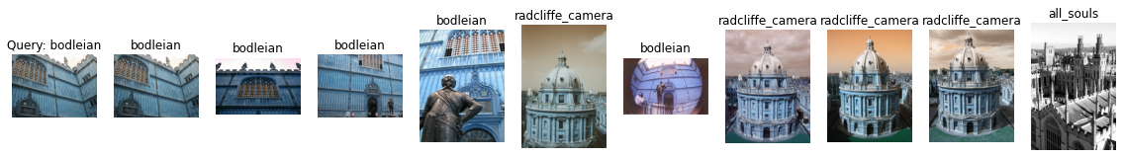

Label: bodleian

Average Precision for query 16: 0.25467463876412405

Precision@k for query 16: 0.5

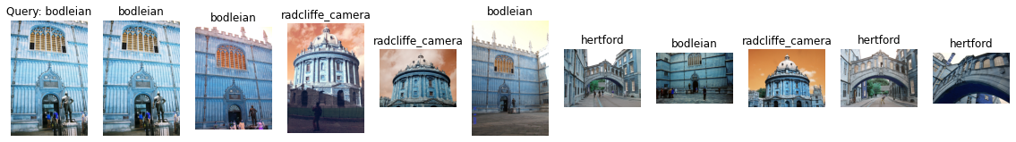

Label: bodleian

Average Precision for query 17: 0.17538690545001656

Precision@k for query 17: 0.4

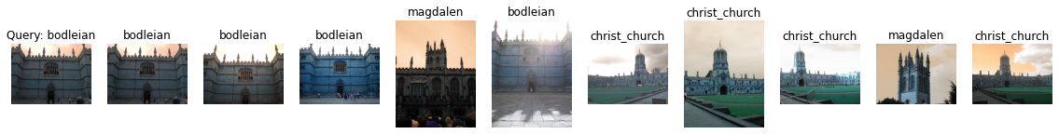

Label: bodleian

Average Precision for query 18: 0.22140636969429658

Precision@k for query 18: 0.4

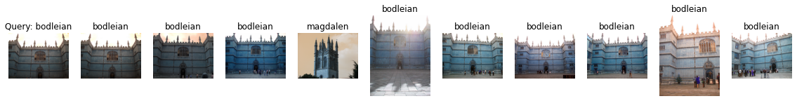

Label: bodleian

Average Precision for query 19: 0.5232632089776454

Precision@k for query 19: 0.9

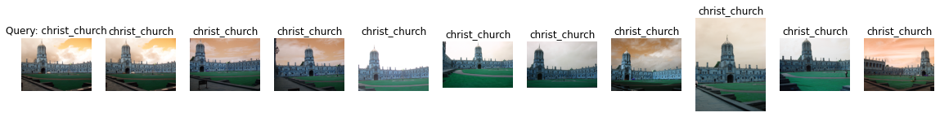

Label: christ_church

Average Precision for query 20: 0.5567927064194579

Precision@k for query 20: 1.0



Label: christ_church

Average Precision for query 21: 0.7302621732642608

Precision@k for query 21: 1.0

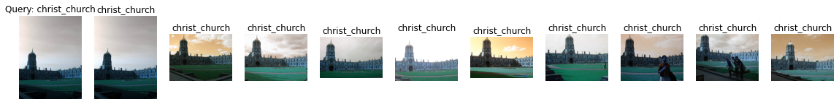

Label: christ_church

Average Precision for query 22: 0.6562456046608058

Precision@k for query 22: 1.0

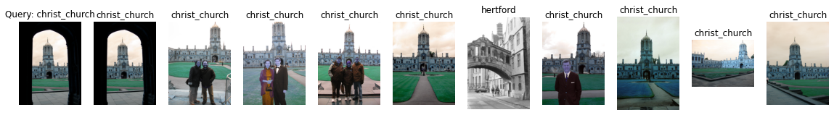

Label: christ_church

Average Precision for query 23: 0.39277139588994703

Precision@k for query 23: 0.9

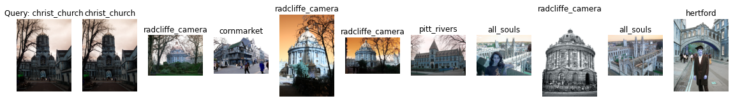

Label: christ_church

Average Precision for query 24: 0.11342977683198804

Precision@k for query 24: 0.1

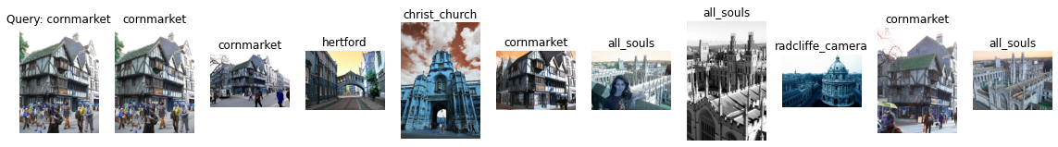

Label: cornmarket

Average Precision for query 25: 0.3633197095108838

Precision@k for query 25: 0.4

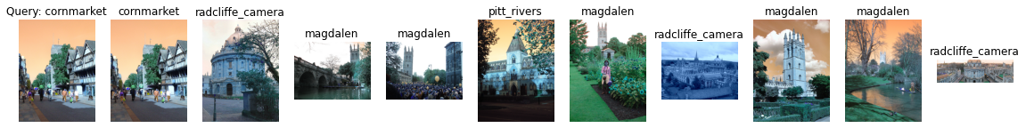

Label: cornmarket

Average Precision for query 26: 0.16067026808170004

Precision@k for query 26: 0.1

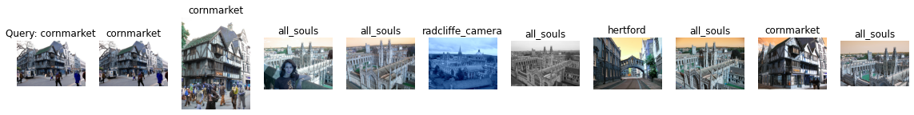

Label: cornmarket

Average Precision for query 27: 0.2950351442204679

Precision@k for query 27: 0.3

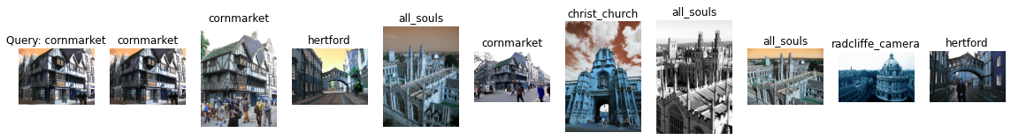

Label: cornmarket

Average Precision for query 28: 0.34562649422278874

Precision@k for query 28: 0.3

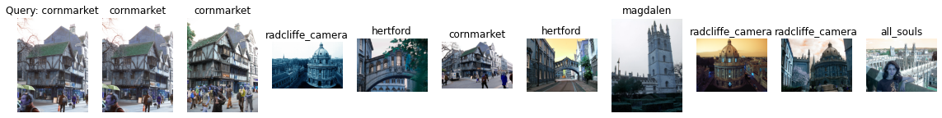

Label: cornmarket

Average Precision for query 29: 0.39170797473318486

Precision@k for query 29: 0.3

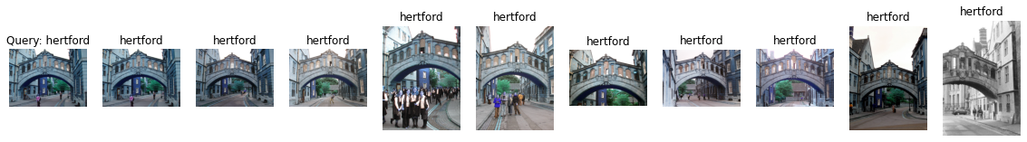

Label: hertford

Average Precision for query 30: 0.6768803282788759

Precision@k for query 30: 1.0

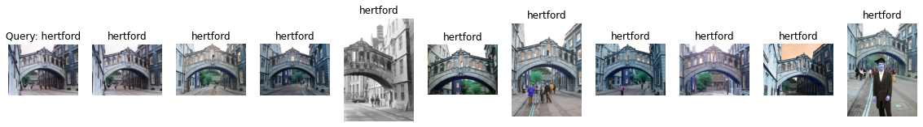

Label: hertford

Average Precision for query 31: 0.6041788301893268

Precision@k for query 31: 1.0

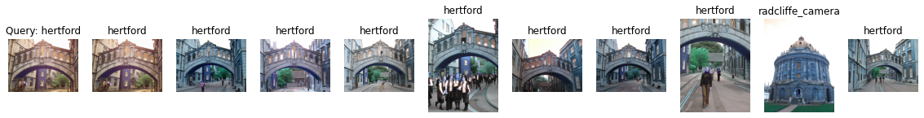

Label: hertford

Average Precision for query 32: 0.49603636264251205

Precision@k for query 32: 0.9

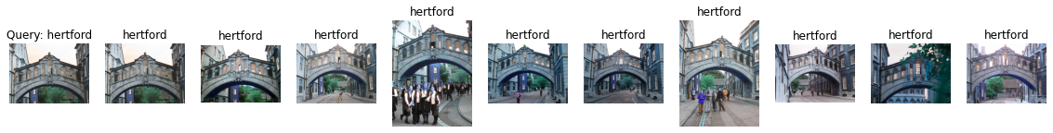

Label: hertford

Average Precision for query 33: 0.5219588242828757

Precision@k for query 33: 1.0

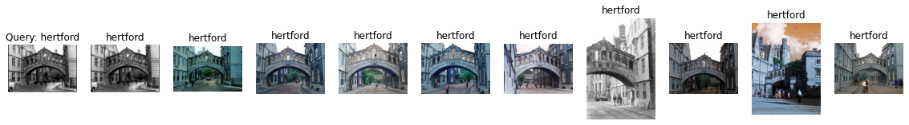

Label: hertford

Average Precision for query 34: 0.7280599484042317

Precision@k for query 34: 1.0

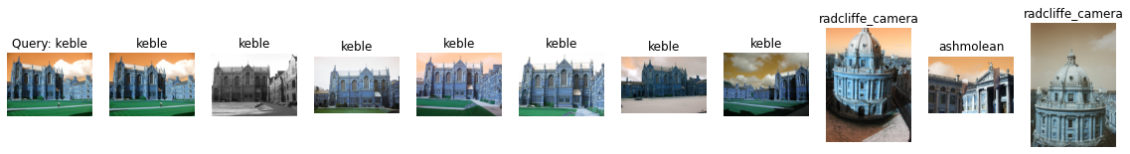

Label: keble

Average Precision for query 35: 1.0

Precision@k for query 35: 0.7

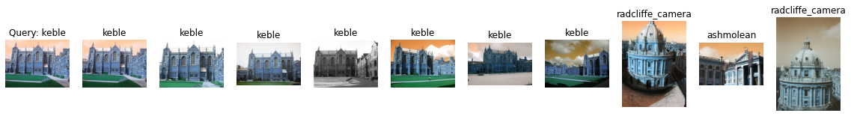

Label: keble

Average Precision for query 36: 1.0

Precision@k for query 36: 0.7

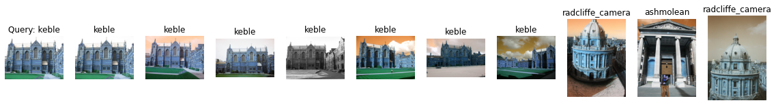

Label: keble

Average Precision for query 37: 1.0

Precision@k for query 37: 0.7

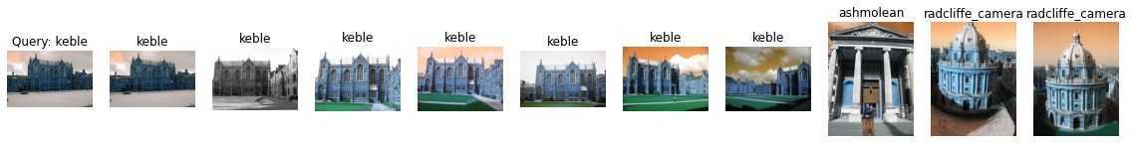

Label: keble

Average Precision for query 38: 1.0

Precision@k for query 38: 0.7

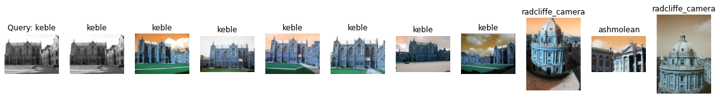

Label: keble

Average Precision for query 39: 1.0

Precision@k for query 39: 0.7

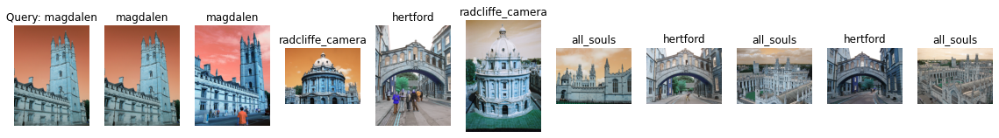

Label: magdalen

Average Precision for query 40: 0.10097851699413497

Precision@k for query 40: 0.2

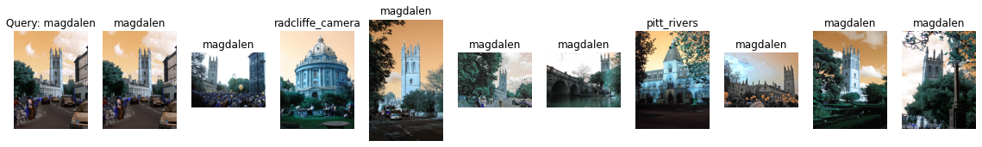

Label: magdalen

Average Precision for query 41: 0.3479417078665289

Precision@k for query 41: 0.8

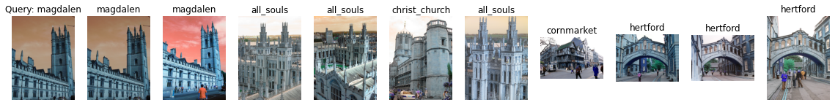

Label: magdalen

Average Precision for query 42: 0.10358456849880791

Precision@k for query 42: 0.2

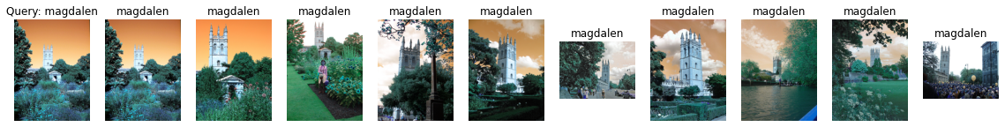

Label: magdalen

Average Precision for query 43: 0.5524530589423636

Precision@k for query 43: 1.0



Label: magdalen

Average Precision for query 44: 0.13249733488897755

Precision@k for query 44: 0.2

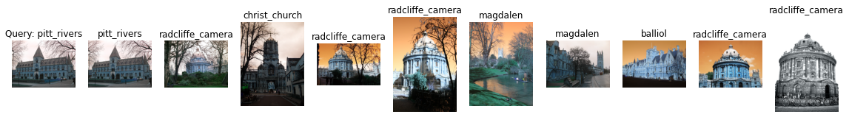

Label: pitt_rivers

Average Precision for query 45: 0.2066879211565971

Precision@k for query 45: 0.1



Label: pitt_rivers

Average Precision for query 46: 0.35648607089821516

Precision@k for query 46: 0.2



Label: pitt_rivers

Average Precision for query 47: 0.18075229370115917

Precision@k for query 47: 0.1

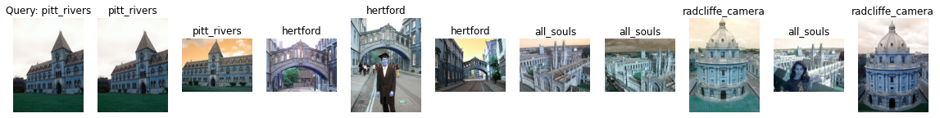

Label: pitt_rivers

Average Precision for query 48: 0.3469622274327835

Precision@k for query 48: 0.2



Label: pitt_rivers

Average Precision for query 49: 0.3586914403946458

Precision@k for query 49: 0.2

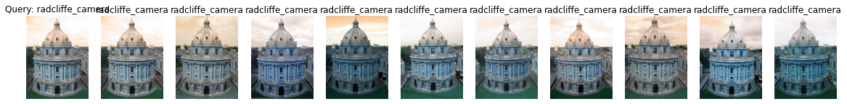

Label: radcliffe_camera

Average Precision for query 50: 0.6461560642420989

Precision@k for query 50: 1.0

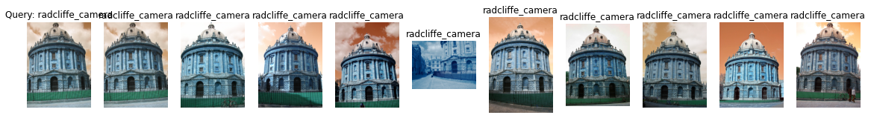

Label: radcliffe_camera

Average Precision for query 51: 0.7799206870330148

Precision@k for query 51: 1.0

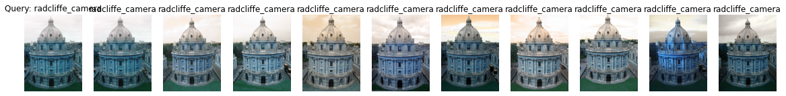

Label: radcliffe_camera

Average Precision for query 52: 0.6805693524701133

Precision@k for query 52: 1.0



Label: radcliffe_camera

Average Precision for query 53: 0.721368140536584

Precision@k for query 53: 1.0

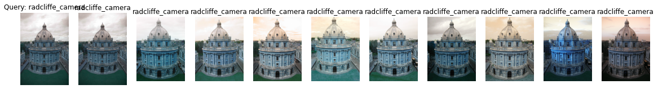

Label: radcliffe_camera

Average Precision for query 54: 0.6567360170839129

Precision@k for query 54: 1.0

mAP = 0.46149390147049507